
AWS Foundation Course – Training Document Virtual Private Cloud (VPC)

USA | UK | Germany | India | UAE | Australia | Malaysia | Singapore | Indonesia
Reimagining a better shared world

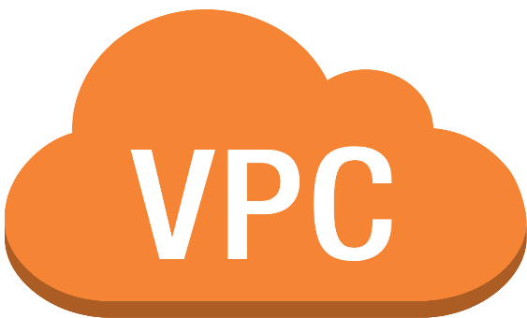
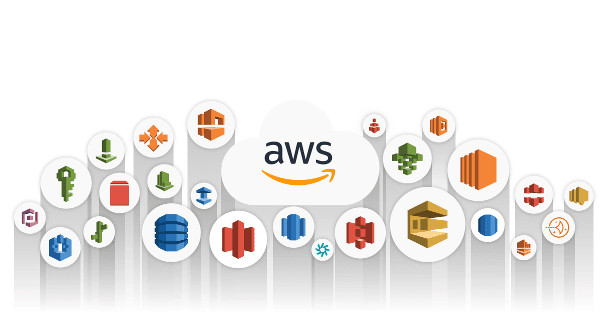

Contents
1. Prerequisites 3
2. Infrastructure Requirements 4
3. Session-wise Course Plan 6
4. Session 1 – Virtual Private Cloud 8
4.1 Objective 8
4.2 Introduction 8
4.3 Architecture of VPC 8
4.4 Features of VPC 9
4.5 Accessing Amazon VPC 10
4.6 How Amazon VPC works 11
4.7 Monitoring VPC Flow logs 13
4.8 VPC with public and private subnets (NAT) - Scenario 16
4.9 Best Practices 18
4.10 Summary 19
4.11 References 20
4.12 Session Recordings 20
4.13 Quiz 20
4.14 Exercises 20

Prerequisites
The following are some of the major pre-requisites:
- Fundamental knowledge of operating systems like Windows, Linux, etc.
- Fundamental knowledge of Networking and Virtualization
- Knowledge of any programming language
- Fundamental command on coding (because certain auxiliary software may need it)
- Overview of Public and Private cloud

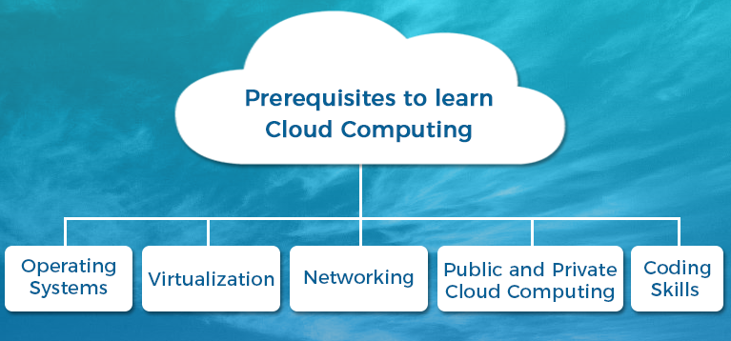

Infrastructure Requirements
- A good configuration laptop with Internet Connection is much sufficient to learn AWS.
- AWS Account with VPC access.

Session-wise Course Plan
Session | Content
1 | - Introduction to Amazon VPC  - Architecture of VPC  - Features of VPC  - How Amazon VPC works  - Monitoring with VPC flow logs  - Best Practices  - Summary

4. Session 1 – Virtual Private Cloud

4.1 Objective
This session introduces Amazon Virtual Private Cloud, its features, architecture, working of VPC, monitoring VPC with flow logs and also a sample scenario.

4.2 Introduction
Amazon Virtual Private Cloud (Amazon VPC) enables you to launch AWS resources into a virtual network that you've defined. This virtual network closely resembles a traditional network that you'd operate in your own data center, with the benefits of using the scalable infrastructure of AWS.

4.3 Architecture of VPC
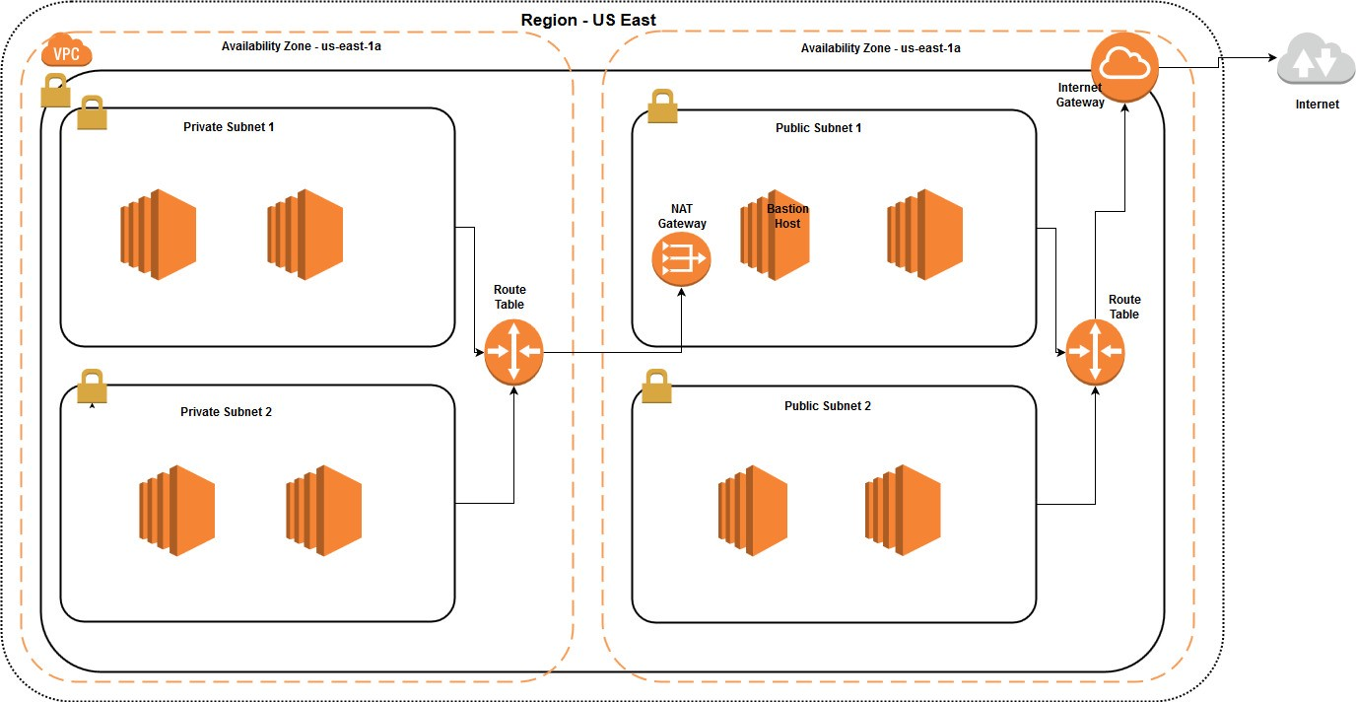

4.4 Features of VPC
The following features help you configure a VPC to provide the connectivity that your applications need:
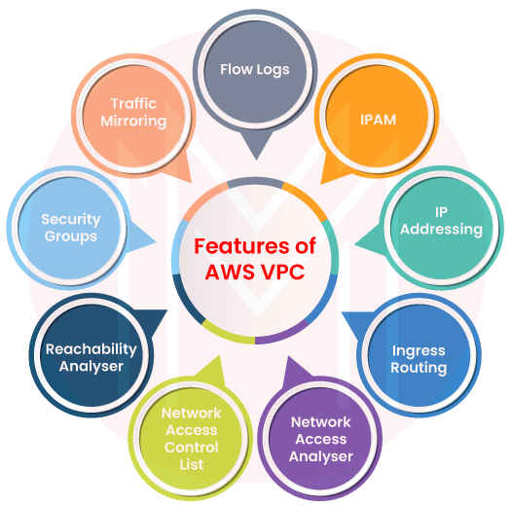
Virtual private clouds (VPC)
A VPC is a virtual network that closely resembles a traditional network that you'd operate in your own data center. After you create a VPC, you can add subnets.
Subnets
A subnet is a range of IP addresses in your VPC. A subnet must reside in a single Availability Zone. After you add subnets, you can deploy AWS resources in your VPC.
IP addressing
You can assign IPv4 addresses and IPv6 addresses to your VPCs and subnets. You can also bring your public IPv4 and IPv6 GUA addresses to AWS and allocate them to resources in your VPC, such as EC2 instances, NAT gateways, and Network Load Balancers.

Routing
Use route tables to determine where network traffic from your subnet or gateway is directed.
Gateways and endpoints
A gateway connects your VPC to another network. For example, use an internet gateway to connect your VPC to the internet. Use a VPC endpoint to connect to AWS services privately, without the use of an internet gateway or NAT device.
Peering connections
Use a VPC peering connection to route traffic between the resources in two VPCs.
Traffic Mirroring
Copy network traffic from network interfaces and send it to security and monitoring appliances for deep packet inspection.
Transit gateways
Use a transit gateway, which acts as a central hub, to route traffic between your VPCs, VPN connections, and AWS Direct Connect connections.
VPC Flow Logs
A flow log captures information about the IP traffic going to and from network interfaces in your VPC.
VPN connections
Connect your VPCs to your on-premises networks using AWS Virtual Private Network (AWS VPN).

4.5 Accessing Amazon VPC
You can create and manage your VPCs using any of the following interfaces:
- AWS Management Console — Provides a web interface that you can use to access your VPCs.
- AWS Command Line Interface (AWS CLI) — Provides commands for a broad set of AWS services, including Amazon VPC, and is supported on Windows, Mac, and Linux.
- AWS SDKs — Provides language-specific APIs and takes care of many of the connection details, such as calculating signatures, handling request retries, and error handling.
- Query API — Provides low-level API actions that you call using HTTPS requests. Using the Query API is the most direct way to access Amazon VPC, but it requires that your application handle low-level details such as generating the hash to sign the request, and error handling.

4.6 How Amazon VPC works
Amazon Virtual Private Cloud (Amazon VPC) enables you to launch AWS resources into a virtual network that you've defined. This virtual network closely resembles a traditional network that you'd operate in your own data center, with the benefits of using the scalable infrastructure of AWS.
VPC and Subnets
A virtual private cloud (VPC) is a virtual network dedicated to your AWS account. It is logically isolated from other virtual networks in the AWS Cloud. You can specify an IP address range for the VPC, add subnets, add gateways, and associate security groups.
A subnet is a range of IP addresses in your VPC. You launch AWS resources, such as Amazon EC2 instances, into your subnets. You can connect a subnet to the internet, other VPCs, and your own data centers, and route traffic to and from your subnets using route tables.
Default and non-default VPCs
If your account was created after 2013-12-04, it comes with a default VPC in each Region. A default VPC is configured and ready for you to use. For example, it has a default subnet in each Availability Zone in the Region, an attached internet gateway, a route in the main route table that sends all traffic to the internet gateway, and DNS settings that automatically assign public DNS hostnames to instances with public IP addresses and enable DNS resolution through the Amazon-provided DNS server (see DNS attributes in your VPC). Therefore, an EC2 instance that is launched in a default subnet automatically has access to the internet. If you have a default VPC in a Region and you don't specify a subnet when you launch an EC2 instance into that Region, we choose one of the default subnets and launch the instance into that subnet.
You can also create your own VPC, and configure it as you need. This is known as a nondefault VPC. Subnets that you create in your nondefault VPC and additional subnets that you create in your default VPC are called nondefault subnets.
IP Addressing
IP addresses enable resources in your VPC to communicate with each other, and with resources over the internet.
Classless Inter-Domain Routing (CIDR) notation is a way of representing an IP address and its network mask. The format of these addresses is as follows:
- An individual IPv4 address is 32 bits, with 4 groups of up to 3 decimal digits. For example, 10.0.1.0.
- An IPv4 CIDR block has four groups of up to three decimal digits, 0-255, separated by periods, followed by a slash and a number from 0 to 32. For example, 10.0.0.0/16.
- An individual IPv6 address is 128 bits, with 8 groups of 4 hexadecimal digits. For example, 2001:0db8:85a3:0000:0000:8a2e:0370:7334.
- An IPv6 CIDR block has four groups of up to four hexadecimal digits, separated by colons, followed by a double colon, followed by a slash and a number from 1 to 128. For example, 2001:db8:1234:1a00::/56.
When you create a VPC, you assign it an IPv4 CIDR block (a range of private IPv4 addresses), an IPv6 CIDR block, or both IPv4 and IPv6 CIDR blocks (dual-stack).
Private IPv4 addresses are not reachable over the internet. IPv6 addresses are globally unique and can be configured to remain private or be reachable over the internet.
Your VPC can operate in dual-stack mode. This means that your resources can communicate over IPv4, IPv6, or both IPv4 and IPv6. IPv4 and IPv6 addresses are independent of each other; you must add separate routes and security group rules for IPv4 and IPv6.
Route Tables
A route table contains a set of rules, called routes, that are used to determine where network traffic from your VPC is directed. You can explicitly associate a subnet with a particular route table. Otherwise, the subnet is implicitly associated with the main route table.
Each route in a route table specifies the range of IP addresses where you want the traffic to go (the destination) and the gateway, network interface, or connection through which to send the traffic (the target).

4.7 Monitoring VPC Flow logs
VPC Flow Logs is a feature that enables you to capture information about the IP traffic going to and from network interfaces in your VPC. Flow log data can be published to the following locations: Amazon CloudWatch Logs, Amazon S3, or Amazon Kinesis Data Firehose. After you create a flow log, you can retrieve and view the flow log records in the log group, bucket, or delivery stream that you configured.
Flow logs can help you with a number of tasks, such as:
- Diagnosing overly restrictive security group rules
- Monitoring the traffic that is reaching your instance
- Determining the direction of the traffic to and from the network interfaces
Flow log data is collected outside of the path of your network traffic, and therefore does not affect network throughput or latency. You can create or delete flow logs without any risk of impact to network performance.
Flow log Basics
You can create a flow log for a VPC, a subnet, or a network interface. If you create a flow log for a subnet or VPC, each network interface in that subnet or VPC is monitored.
Flow log data for a monitored network interface is recorded as flow log records, which are log events consisting of fields that describe the traffic flow. For more information, see Flow log records.
To create a flow log, you specify:
- The resource for which to create the flow log
- The type of traffic to capture (accepted traffic, rejected traffic, or all traffic)
- The destinations to which you want to publish the flow log data
In the following example, you create a flow log that captures accepted traffic for the network interface for one of the EC2 instances in a private subnet and publishes the flow log records to an Amazon S3 bucket.
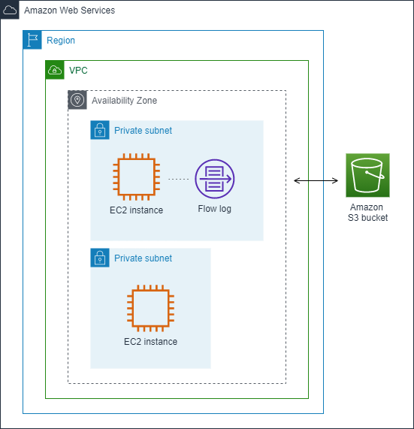
Flow log records
A flow log record represents a network flow in your VPC. By default, each record captures a network internet protocol (IP) traffic flow (characterized by a 5-tuple on a per network interface basis) that occurs within an aggregation interval, also referred to as a capture window.
Each record is a string with fields separated by spaces. A record includes values for the different components of the IP flow, for example, the source, destination, and protocol.
When you create a flow log, you can use the default format for the flow log record, or you can specify a custom format.
Aggregation Interval
The aggregation interval is the period of time during which a particular flow is captured and aggregated into a flow log record. By default, the maximum aggregation interval is 10 minutes. When you create a flow log, you can optionally specify a maximum aggregation interval of 1 minute. Flow logs with a maximum aggregation interval of 1 minute produce a higher volume of flow log records than flow logs with a maximum aggregation interval of 10 minutes.
When a network interface is attached to a Nitro-based instance, the aggregation interval is always 1 minute or less, regardless of the specified maximum aggregation interval.
After data is captured within an aggregation interval, it takes additional time to process and publish the data to CloudWatch Logs or Amazon S3. The flow log service typically delivers logs to CloudWatch Logs in about 5 minutes and to Amazon S3 in about 10 minutes. However, log delivery is on a best effort basis, and your logs might be delayed beyond the typical delivery time.
Default format
With the default format, the flow log records include the version 2 fields, in the order shown in the available fields table. You cannot customize or change the default format. To capture additional fields or a different subset of fields, specify a custom format instead.

Custom format
With a custom format, you specify which fields are included in the flow log records and in which order. This enables you to create flow logs that are specific to your needs and to omit fields that are not relevant. Using a custom format can reduce the need for separate processes to extract specific information from the published flow logs. You can specify any number of the available flow log fields, but you must specify at least one.

4.8 VPC with public and private subnets (NAT) - Scenario
The configuration for this scenario includes a virtual private cloud (VPC) with a public subnet and a private subnet. We recommend this scenario if you want to run a public-facing web application, while maintaining back-end servers that aren't publicly accessible. A common example is a multi-tier website, with the web servers in a public subnet and the database servers in a private subnet. You can set up security and routing so that the web servers can communicate with the database servers.
The instances in the public subnet can send outbound traffic directly to the internet, whereas the instances in the private subnet can't. Instead, the instances in the private subnet can access the internet by using a network address translation (NAT) gateway that resides in the public subnet. The database servers can connect to the internet for software updates using the NAT gateway, but the internet cannot establish connections to the database servers.
This scenario can also be optionally configured for IPv6. Instances launched into the subnets can receive IPv6 addresses, and communicate using IPv6. Instances in the private subnet can use an egress-only internet gateway to connect to the internet over IPv6, but the internet cannot establish connections to the private instances over IPv6.
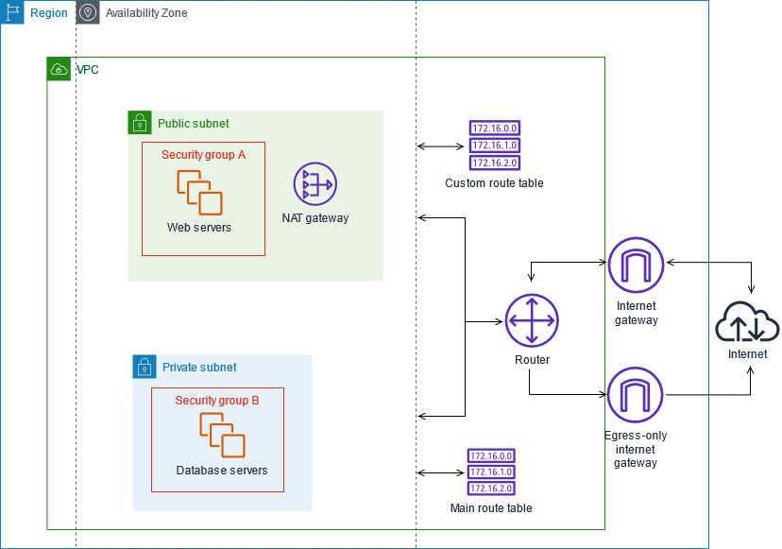
The configuration for this scenario includes the following:
- A VPC with a size /16 IPv4 CIDR block (example: 10.0.0.0/16). This provides 65,536 private IPv4 addresses.
- A public subnet with a size /24 IPv4 CIDR block (example: 10.0.0.0/24). This provides 256 private IPv4 addresses. A public subnet is a subnet that's associated with a route table that has a route to an internet gateway.
- A private subnet with a size /24 IPv4 CIDR block (example: 10.0.1.0/24). This provides 256 private IPv4 addresses.
- An internet gateway. This connects the VPC to the internet and to other AWS services.
- Instances with private IPv4 addresses in the subnet range (examples: 10.0.0.5, 10.0.1.5). This enables them to communicate with each other and other instances in the VPC.
- Instances in the public subnet with Elastic IPv4 addresses (example: 198.51.100.1), which are public IPv4 addresses that enable them to be reached from the internet. The instances can have public IP addresses assigned at launch instead of Elastic IP addresses. Instances in the private subnet are back-end servers that don't need to accept incoming traffic from the internet and therefore do not have public IP addresses; however, they can send requests to the internet using the NAT gateway (see the next bullet).
- A NAT gateway with its own Elastic IPv4 address. Instances in the private subnet can send requests to the internet through the NAT gateway over IPv4 (for example, for software updates).
- A custom route table associated with the public subnet. This route table contains an entry that enables instances in the subnet to communicate with other instances in the VPC over IPv4, and an entry that enables instances in the subnet to communicate directly with the internet over IPv4.
- The main route table associated with the private subnet. The route table contains an entry that enables instances in the subnet to communicate with other instances in the VPC over IPv4, and an entry that enables instances in the subnet to communicate with the internet through the NAT gateway over IPv4.

4.9 Best Practices
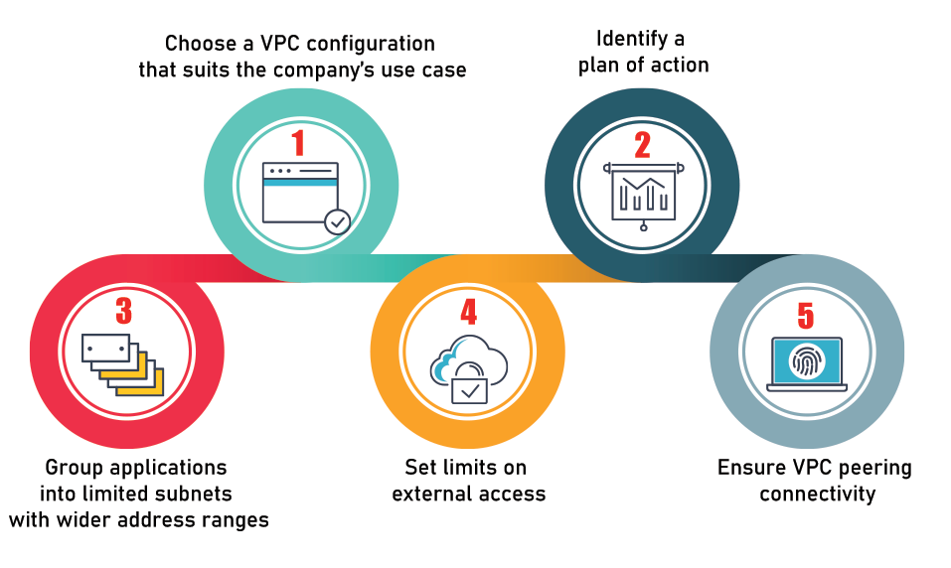
Public and private subnets
You should use private subnets to secure resources that don't need to be available to the internet, such as database services. It enables the flexibility to launch a service in the subnets.

Provide NAT to private subnets
To provide secure internet access to instances that reside in your private subnets, you should leverage a NAT device.
Use NAT gateways
When using NAT devices, you should use the NAT gateway over NAT instances because they are managed services and require less administration. It also provides secure internet access to your private subnets.
CIDR blocks
You should choose CIDR blocks carefully; Amazon VPC can contain anywhere from 16 to 65,536 IP addresses. You can select your CIDR block according to the number of instances needed.
Create different VPCs for different environments
You should also create a separate Amazon VPC for development, staging, and test and production environments. Another option is to create an Amazon VPC with separate subnets with a subnet for each production, development, staging, and tests.

4.10 Summary
- Security: Security is the most important perk of VPC. Advanced security is offered by VPC in AWS at the instance and subnet levels. You can specify which users have access to cloud resources and which ones do not with VPC. Security is the most important perk of VPC. Advanced security is offered by VPC in AWS at the instance and subnet levels. You can specify which users have access to cloud resources and which ones do not with VPC.
- Easy to Set up and Use: As with all of AWS’s services, AWS VPC is simple to set up. The AWS Management Console makes it simple to set up an Amazon VPC. The default VPC for your account is already set up, allowing you to concentrate on developing and delivering apps.
- Application Performance: Application performance is largely affected by the congestion on the Internet. It can slow down the application traffic or even make the application slow.

4.11 References
https://docs.aws.amazon.com/vpc/latest/userguide/what-is-amazon-vpc.html

4.12 Session Recordings
https://videos.htcindia.com/AVideo/vEmbed/996

4.13 Quiz
Refer the AWS foundation Course in learning portal.

4.14 Exercises
Refer the AWS foundation Course in learning portal.

